**Project Report**

1. **Introduction**

**1.1 Overview:**

iPhone is a line of smartphones produced by Apple Inc. that use Apple's own iOS mobile operating system. The first-generation iPhone was announced by then-Apple CEO Steve Jobs on January 9, 2007. Since then, Apple has annually released new iPhone models and iOS updates. As of November 1, 2018, more than 2.2 billion iPhones had been sold.

**1.2 Purpose:**

Before the iPhone, mobile phones were clunky devices with physical keyboards and limited features. They were mainly used for email, and basic internet browsing and geared mainly towards business users.

**2.Problem Definition & Design Thinking**

**2.1 Empathy Map**

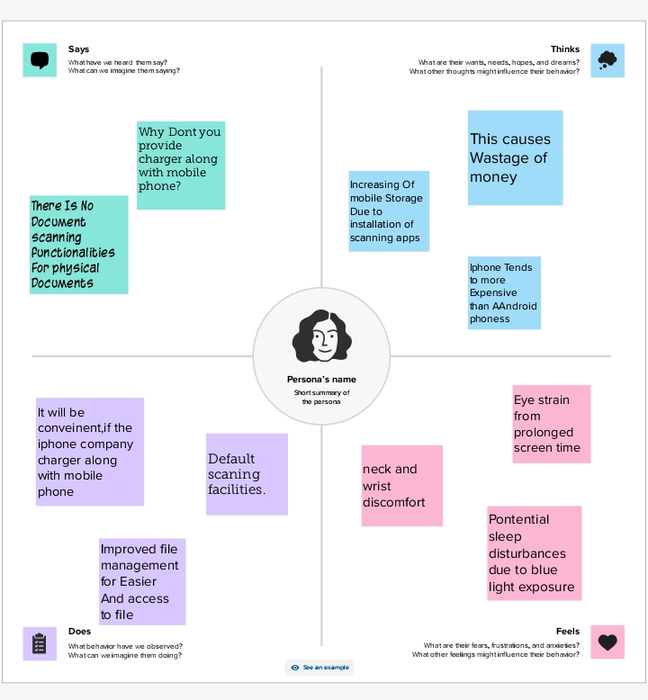

**2.2 Brain Storming**  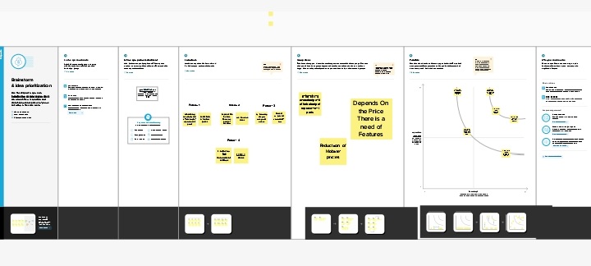

**3. Result**

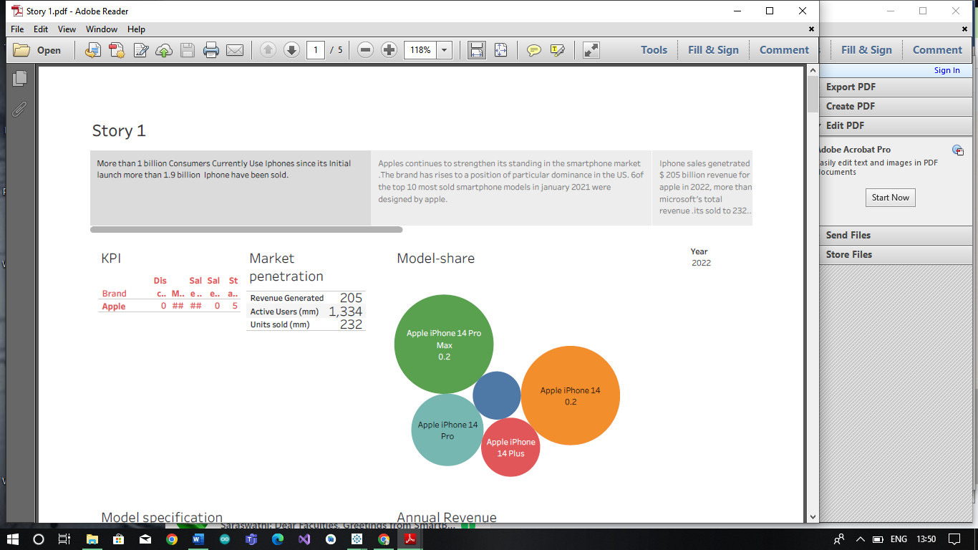

**4.Advantages & Disadvantage**

**4.1 Advantages of the iPhone:**

1. It is an Device which is user friendly

2. It has an High Quality Display.

3.IPhone had Advanced Camera. It helps to reduce blur and take better pictures in low light.

4. It allows users to access and transfer data across multiple devices.

**Disadvantages of the iPhone:**

1. High-end models can cost over $1000, which makes it a luxury item for many people.

2. The iPhone’s batteries are non-removable, which means that users cannot replace them.

3. Users cannot customize their phone’s interface, which can be a disadvantage for some people.

4. iPhone has no expandable storage options. Users have to purchase

**5. Application**

1)Start the day with the info you need While iPhone is charging, you can put it in Stand By to view useful and timely information at a glance.

2)Get directions to your favourite places.

3)Set up a virtual wallet by this you can use it to make secure payments in stores and online, and send and receive money from friends and family.

4)Reminders when you need them You can use the Reminders app to make to-do lists for projects around the house and grocery lists that sort items into categories.

5)With the Home app on iPhone, you can securely control Home Kit-enabled accessories, such as lights, smart TVs, and thermostats from anywhere.

**6.Conclusion**

In summary, it is apparent that the iPhone was, and still, a remarkable invention of technological advancement. The iPhone provided a new way of mobile phone communication and usability. Its revolutionary technology has led to the variety of smartphones that are in use today. The iPhone success story has not been without unethical business practices by Apple Inc., security concerns and social problems. However, these controversies cannot erase the fact that the iPhone stands out as major technological innovation of the 21st Century.

**7.Future Scope**

When it comes to the future of iPhones, there's always something exciting on the horizon. Apple is constantly innovating and introducing new features with each new release. As for unfulfilled features, it's hard to say for sure, but Apple is known for surprising us with their advancements. Let's keep our fingers crossed for some amazing features in the future**.**